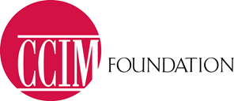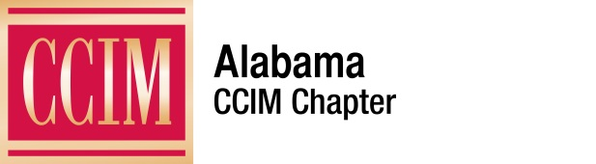

2017 Named Endowed Scholarship Program Application

The BILL BARNHILL, CCIM, Scholarship honors BILL BARNHILL, CCIM, for their contributions to the commercial real estate industry. The Scholarship was funded by the CCIM Foundation and members of the Alabama CCIM Chapter. Named endowed scholarships honor those who have shown great dedication, commitment, outstanding achievement and service to the commercial real estate industry. With this scholarship, the Alabama CCIM Chapter will award an annual recipient with $1,000 toward the reimbursement of tuition for one of the four core courses of CCIM Institute successfully passed.

The Alabama CCIM Chapter serves as the focal point for quality education, networking and market services for the commercial investment real estate specialist in Alabama, by offering resources enabling the commercial investment practitioner to deliver superior service to clients and customers. For more information about the Alabama CCIM Chapter visit http://www.ccimconnect.com/alabama/home

CCIM Foundation is a 501(c)(3) nonprofit organization. The mission of CCIM Foundation is to advance and foster commercial real estate education through scholarships, programs and initiatives. CCIM Foundation has been granting scholarships to deserving students and real estate professionals since 1988. Scholarship programs are designed to encourage and assist professionals pursuing the CCIM designation and to promote high education standards. For more information about CCIM Foundation, visit www.ccimef.org or call 312-321-4491.

Date Submitted: __________Chapter: _________________________________________
Applicant's Name: ________________________________________________________
Company: ______________________________________________________________
Work Address: ___________________________________________________________
City/State/Zip____________________________________________________________
Work Phone Number: __________________Email: ______________________________
Home Address: ___________________________________________________________
City/State/Zip____________________________________________________________

Scholarship Application
Page Two of Two

How many years have you been involved in the real estate industry? ________________

Have you taken CRE Negotiations? Yes No
Do you plan to obtain the CCIM designation? Yes No

What other CCIM CI Classes have you taken? (Please Circle) CI 101 CI 102 CI 103 CI 104
Please include the following with this application:
- Current Resume
- One professional reference
- Typed letter which includes answers to the following questions:
  - Why do you want to become a CCIM?
  - What are your contributing achievements to your company and/or industry?
  - What are your career goals?
  - Would you take the course even if the scholarship were not available and why?
  - What is your personal experience, training and/or internship in Real Estate?

Reference:

Provide one professional reference below.

Name: ____________________________________ Position/Relationship: _________________
Address: ______________________________________________________________________
Email Address: _________________________________________________________________
Phone Number: _________________________________________________________________
Length of time you have known this person: _____________________

By submitting this application, I agree that in the event I am chosen to receive a scholarship, the CCIM Education Foundation and/or CCIM Institute and Chapters may use my name, likeness and/or profile in printed and electronic promotional materials.

By:__________________________________________________________________________
Applicant Date of Submission

Submission:
Return completed application, resume, and essay to the Alabama CCIM Chapter, electronically via email to Scholarship Chair, Terri Dean, CCIM, at terri@deancre.com for review by committee, and Amy Adkins at amy@alabamaccim.com by Friday, April 21, 2017.

